**CSA1539 – Theory of Computation with Model**

**(PRACTICALS)**

**1.DFA**

#include<stdio.h>

#include<string.h>

#define max 20

int main()

{

int trans_table[4][2]={{1,3},{1,2},{1,2},{3,3}};

int final_state=2,i;

int present_state=0;

int next_state=0;

int invalid=0;

char input_string[max];

printf("Enter a string:");

scanf("%s",input_string);

int l=strlen(input_string);

for(i=0;i<l;i++)

{

if(input_string[i]=='a')

next_state=trans_table[present_state][0];

else if(input_string[i]=='b')

next_state=trans_table[present_state][1];

else

invalid=l;

present_state=next_state;

}

if(invalid==l)

{

printf("Invalid input");

}

else if(present_state==final_state)

printf("Accept\n");

else

printf("Don't Accept\n");

}

**OUTPUT:**

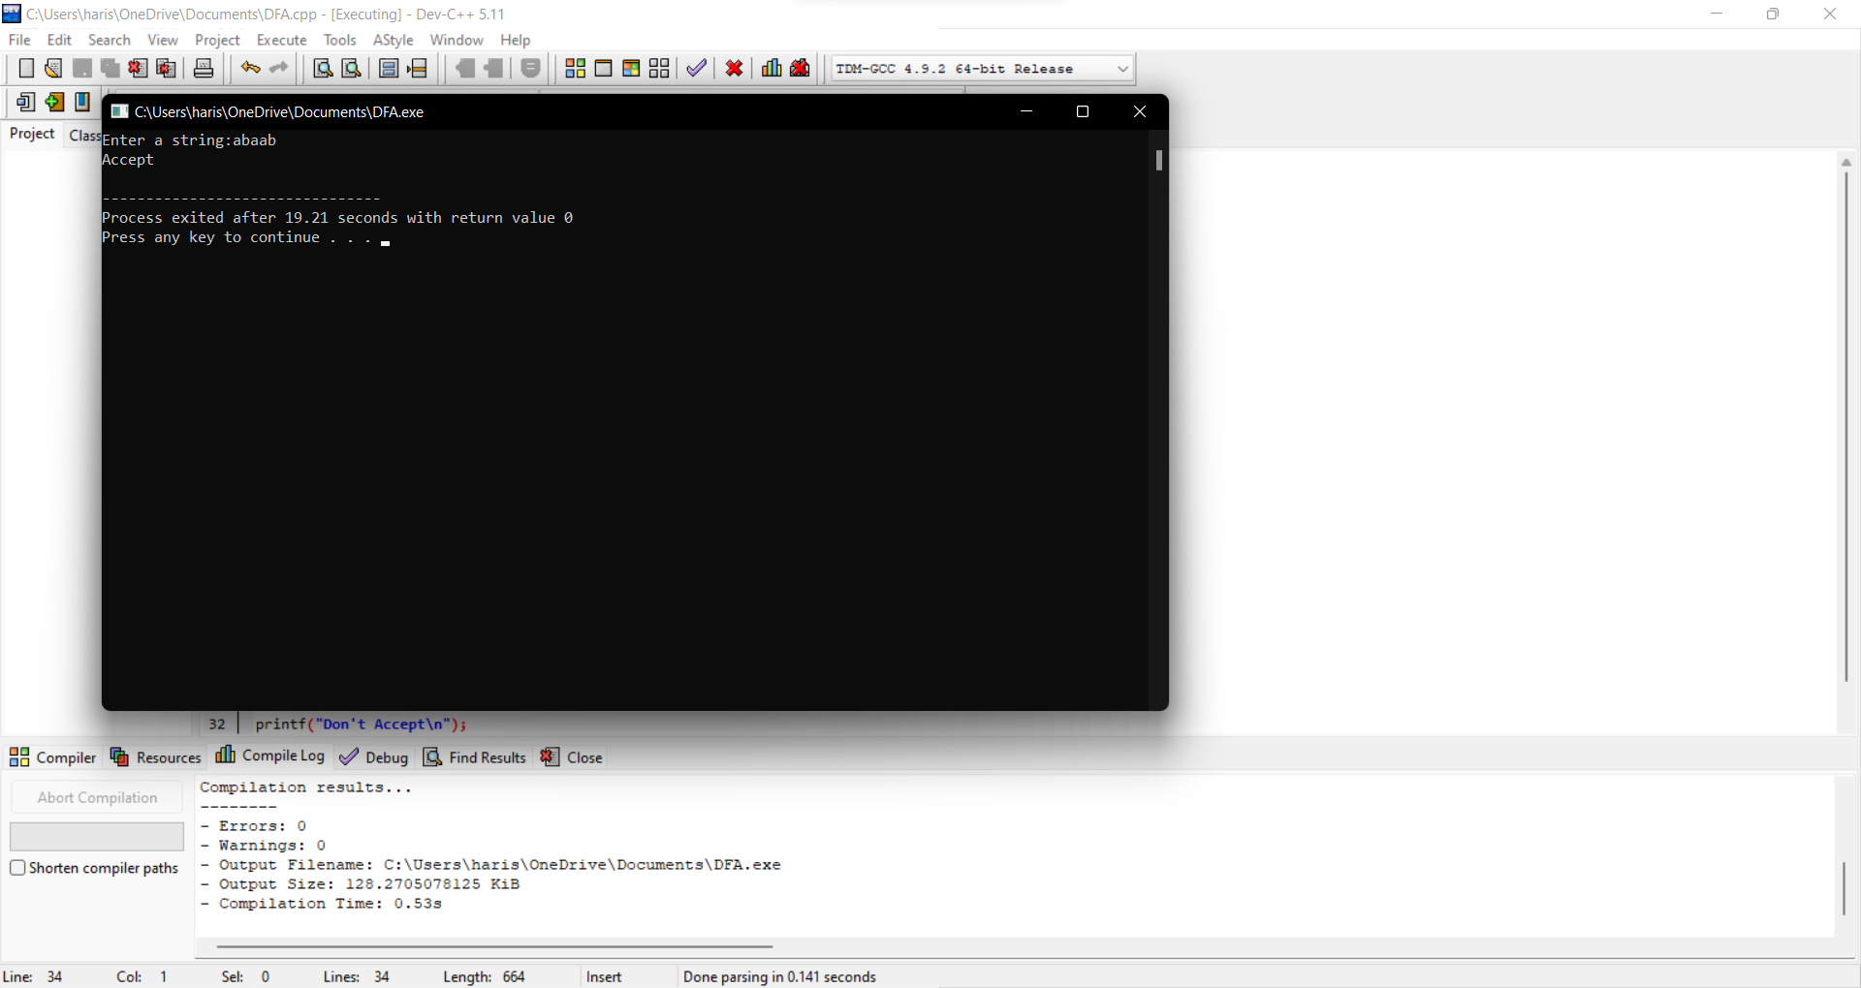

**2.NFA**

#include<stdio.h>

#include<string.h>

int main()

{

int i,j,k,l,m,next_state[20],n,mat[10][10][10],flag,p;

int num_states,final_state[5],num_symbols,num_final;

int present_state[20],prev_trans,new_trans;

char ch,input[20];

int symbol[5],inp,inp1;

printf("How many states in the NFA : ");

scanf("%d",&num_states);

printf("How many symbols in the input alphabet : ");

scanf("%d",&num_symbols);

for(i=0;i<num_symbols;i++)

{

printf("Enter the input symbol %d : ",i+1);

scanf("%d",&symbol[i]);

}

printf("How many final states : ");

scanf("%d",&num_final);

for(i=0;i<num_final;i++)

{

printf("Enter the final state %d : ",i+1);

scanf("%d",&final_state[i]);

}

for(i=0;i<10;i++)

{

for(j=0;j<10;j++)

{

for(k=0;k<10;k++)

{

mat[i][j][k]=-1;

}

}

}

for(i=0;i<num_states;i++)

{

for(j=0;j<num_symbols;j++)

{

printf("How many transitions from state %d for the input %d :",i,symbol[j]);

scanf("%d",&n);

for(k=0;k<n;k++)

{

printf("Enter the transition %d from state %d for the input %d :" ,k+1,i,symbol[j]);

scanf("%d",&mat[i][j][k]);

}

}

}

printf("The transitions are stored as shown below\n");

for(i=0;i<10;i++)

{

for(j=0;j<10;j++)

{

for(k=0;k<10;k++)

{

if(mat[i][j][k]!=-1)

printf("mat[%d][%d][%d] = %d\n",i,j,k,mat[i][j][k]);

}

}

}

while(1)

{

printf("Enter the input string : ");

scanf("%s",input);

present_state[0]=0;

prev_trans=1;

l=strlen(input);

for(i=0;i<l;i++)

{

if(input[i]=='0')

inp1=0;

else if(input[i]=='1')

inp1=1;

else

{

printf("Invalid input\n");

exit(0);

}

for(m=0;m<num_symbols;m++)

{

if(inp1==symbol[m])

{

inp=m;

break;

}

}

new_trans=0;

for(j=0;j<prev_trans;j++)

{

k=0;

p=present_state[j];

while(mat[p][inp][k]!=-1)

{

next_state[new_trans++]=mat[p][inp][k];

k++;

}

}

for(j=0;j<new_trans;j++)

{

present_state[j]=next_state[j];

}

prev_trans=new_trans;

}

flag=0;

for(i=0;i<prev_trans;i++)

{

for(j=0;j<num_final;j++)

{

if(present_state[i]==final_state[j])

{

flag=1;

break;

}

}

}

if(flag==1)

printf("Acepted\n");

else

printf("Not accepted\n");

printf("Try with another input\n");

}

}

**OUTPUT:**

**3.NFA Closure**

#include<stdio.h>

#include<string.h>

int trans_table[10][5][3];

char symbol[5],a;

int e_closure[10][10],ptr,state;

void find_e_closure(int x);

int main()

{

int i,j,k,n,num_states,num_symbols;

for(i=0;i<10;i++)

{

for(j=0;j<5;j++)

{

for(k=0;k<3;k++)

{

trans_table[i][j][k]=-1;

}

}

}

printf("How may states in the NFA with e-moves:");

scanf("%d",&num_states);

printf("How many symbols in the input alphabet including e :");

scanf("%d",&num_symbols);

printf("Enter the symbols without space. Give 'e' first:");

scanf("%s",symbol);

for(i=0;i<num_states;i++)

{

for(j=0;j<num_symbols;j++)

{

printf("How many transitions from state %d for the input%c:",i,symbol[j]);

scanf("%d",&n);

for(k=0;k<n;k++)

{

printf("Enter the transitions %d from state %d for the input%c :", k+1,i,symbol[j]);

scanf("%d",&trans_table[i][j][k]);

}

}

}

for(i=0;i<10;i++)

{

for(j=0;j<10;j++)

{

e_closure[i][j]=-1;

}

}

for(i=0;i<num_states;i++)

e_closure[i][0]=i;

for(i=0;i<num_states;i++)

{

if(trans_table[i][0][0]==-1)

continue;

else

{

state=i;

ptr=1;

find_e_closure(i);

}

}

for(i=0;i<num_states;i++)

{

printf("e-closure(%d)= {",i);

for(j=0;j<num_states;j++)

{

if(e_closure[i][j]!=-1)

{

printf("%d, ",e_closure[i][j]);

}

}

printf("}\n");

}

}

void find_e_closure(int x)

{

int i,j,y[10],num_trans;

i=0;

while(trans_table[x][0][i]!=-1)

{

y[i]=trans_table[x][0][i];

i=i+1;

}

num_trans=i;

for(j=0;j<num_trans;j++)

{

e_closure[state][ptr]=y[j];

ptr++;

find_e_closure(y[j]);

}

}

**OUTPUT:**

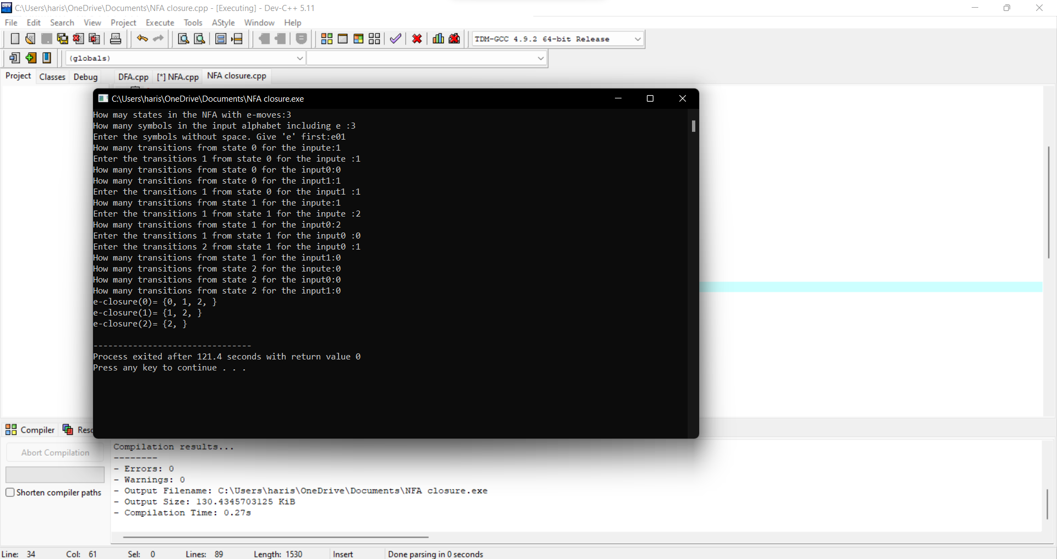

**STRING TO GRAMMER**

**4a.**

#include<stdio.h>

#include<string.h>

int main(){

char s[100];

int i,flag;

int l;

printf("enter a string to check:");

scanf("%s",s);

l=strlen(s);

flag=1;

for(i=0;i<l;i++)

{

if(s[i]!='0' && s[i]!='1')

{

flag=0;

}

}

if(flag!=1)

printf("string is Not Valid\n");

if(flag==1)

{

if (s[0]=='0'&&s[l-1]=='1')

printf("string is accepted\n");

else

printf("string is Not accepted\n");

}

}

**OUTPUT:**

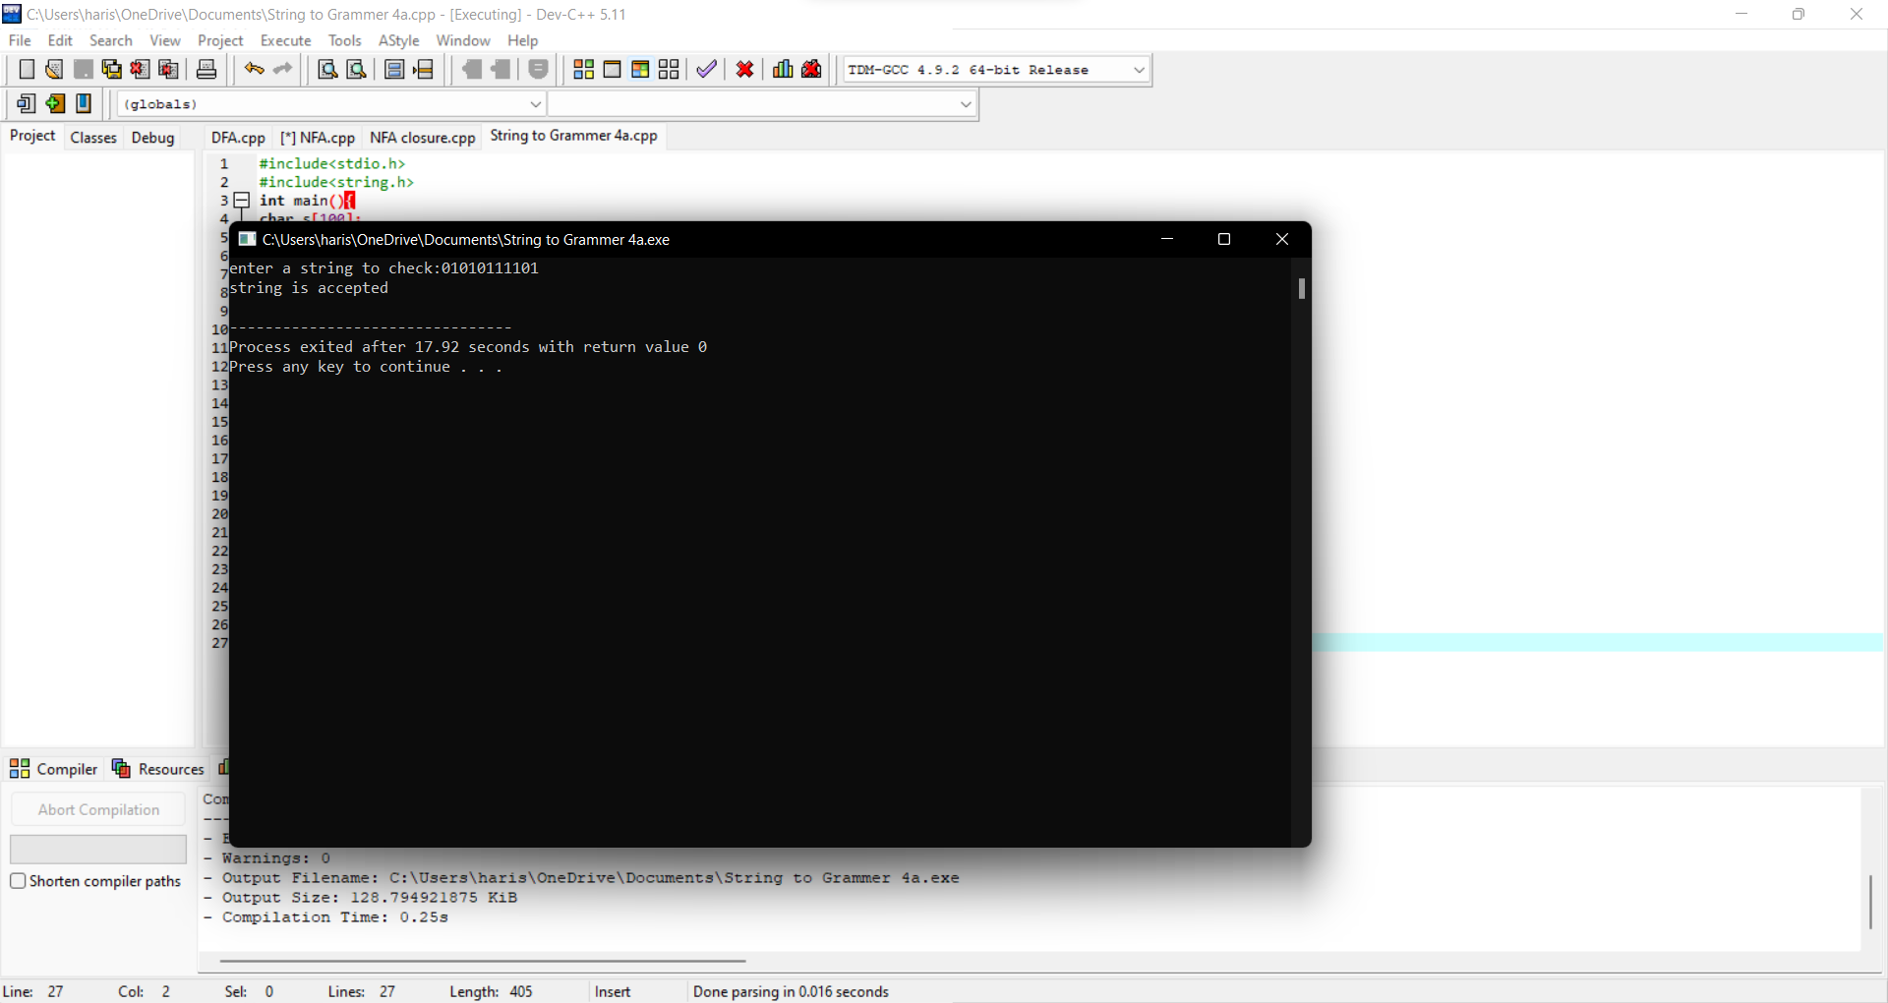

**4b.**

#include<stdio.h>

#include<string.h>

void main()

{

char s[100];

int i,flag,flag1,a,b;

int l;

printf("enter a string to check:");

scanf("%s",s);

l=strlen(s);

flag=1;

for(i=0;i<l;i++)

{

if(s[i]!='0' && s[i]!='1')

{

flag=0;

}

}

if(flag!=1)

printf("string is Not Valid\n");

if(flag==1)

{

flag1=1;

a=0;b=l-1;

while(a!=(l/2))

{

if(s[a]!=s[b])

{

flag1=0;

}

a=a+1;

b=b-1;

}

if (flag1==1)

{

printf("The string is a palindrome\n");

printf("string is accepted\n");

}

else

{

printf("The string is not a palindrome\n");

printf("string is Not accepted\n");

}

}

}

**OUTPUT:**

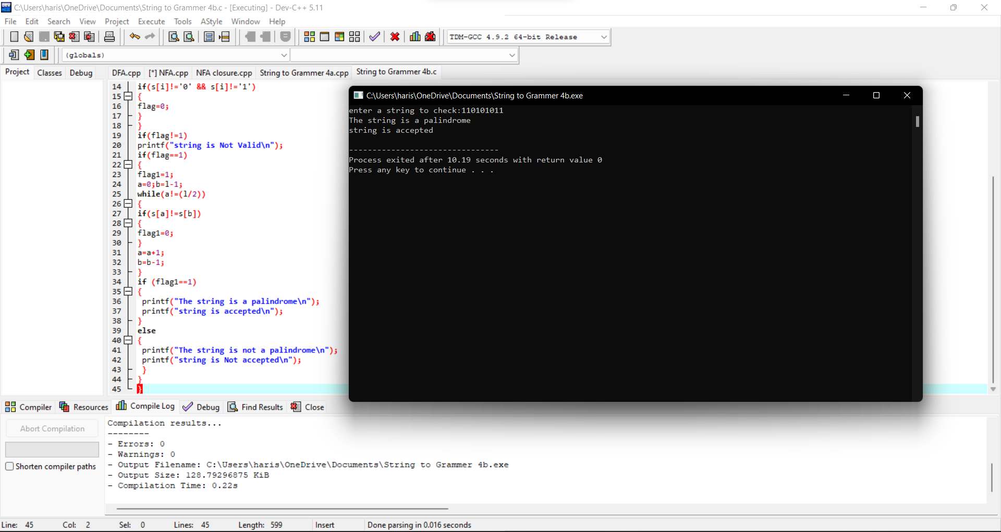

**4c.**

#include<stdio.h>

#include<string.h>

void main()

{

char s[100];

int i,flag,flag1,a,b;

int l,count1,count2;

printf("enter a string to check:");

scanf("%s",s);

l=strlen(s);

flag=1;

for(i=0;i<l;i++)

{

if(s[i]!='0' && s[i]!='1')

{

flag=0;

}

}

if(flag!=1)

printf("string is Not Valid\n");

if(flag==1)

{

i=0;count1=0;

while(s[i]=='0')

{

count1++;

i++;

}

while(s[i]=='1')

{

i++;

}

flag1=1;

count2=0;

while(i<l)

{

if(s[i]=='0')

{

count2++;

}

else

{

flag1=0;

}

i++;

}

if(flag1==1)

{

if(count1==count2)

{

printf("The string satisfies the condition 0n1m0n\n");

printf("String Accepted\n");

}

else

{

printf("The string does not satisfy the condition 0n1m0n\n");

printf("String Not Accepted\n");

}

}

else

{

printf("The string does not satisfy the condition 0n1m0n\n");

printf("String Not Accepted\n");

}

}

}

**OUTPUT:**

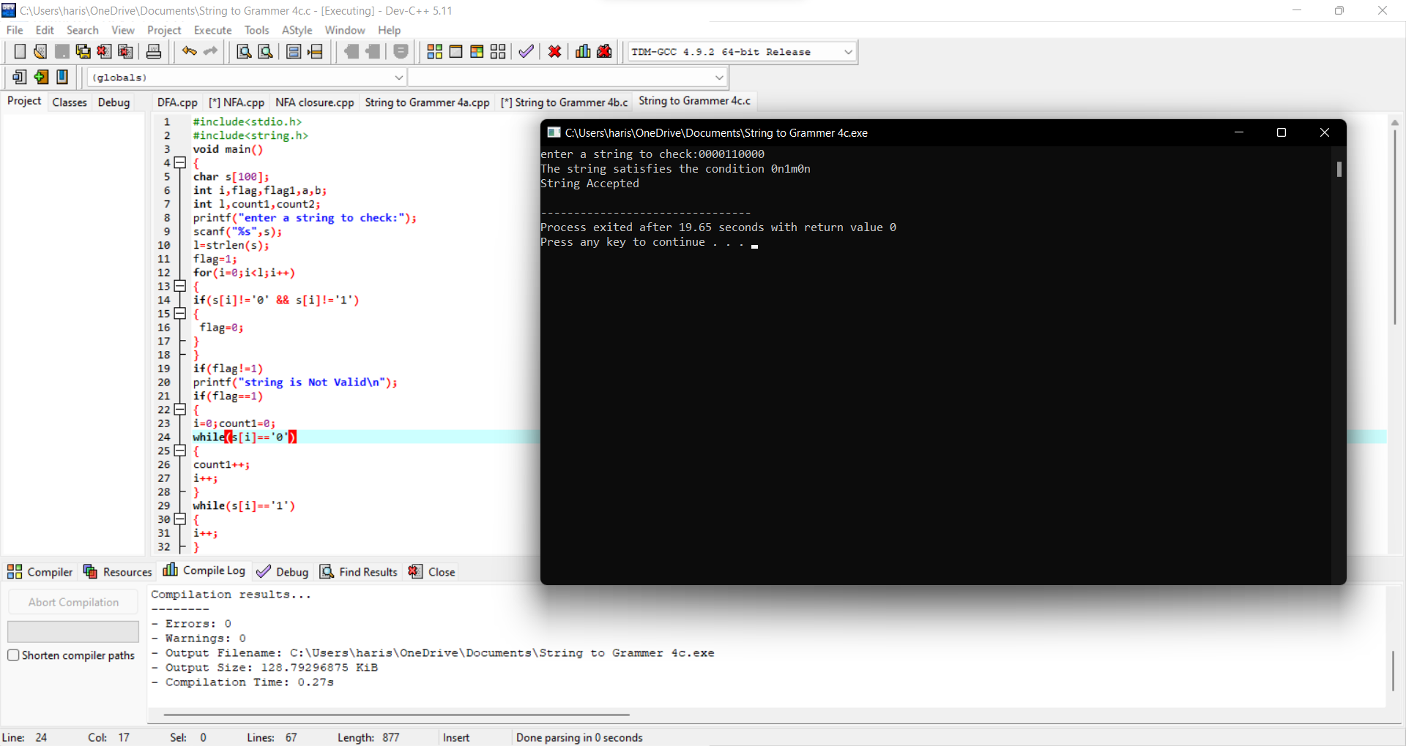

**4D.**

#include<stdio.h>

#include<string.h>

void main()

{

char s[100];

int i,flag,flag1,flag2;

int l;

printf("enter a string to check:");

scanf("%s",s);

l=strlen(s);

flag=1;

for(i=0;i<l;i++)

{

if(s[i]!='0' && s[i]!='1')

{

flag=0;

}

}

if(flag!=1)

printf("string is Not Valid\n");

if(flag==1)

{

if(l%2!=0) // If string length is odd

{

printf("The string does not satisfy the condition 0n1n\n");

printf("String Not Accepted\n");

}

else

{

flag1=1;

for(i=0;i<(l/2);i++)

{

if(s[i]!='0')

{

flag1=0;

}

}

flag2=1;

for(i=l/2;i<l;i++)

{

if(s[i]!='1')

{

flag2=0;

}

}

if(flag1==1 && flag2==1)

{

printf("The string satisfies the condition 0n1n\n");

printf("String Accepted\n");

}

else

{

printf("The string does not satisfy the condition 0n1n\n");

printf("String Not Accepted\n");

}

}

}

}

**OUTPUT:**

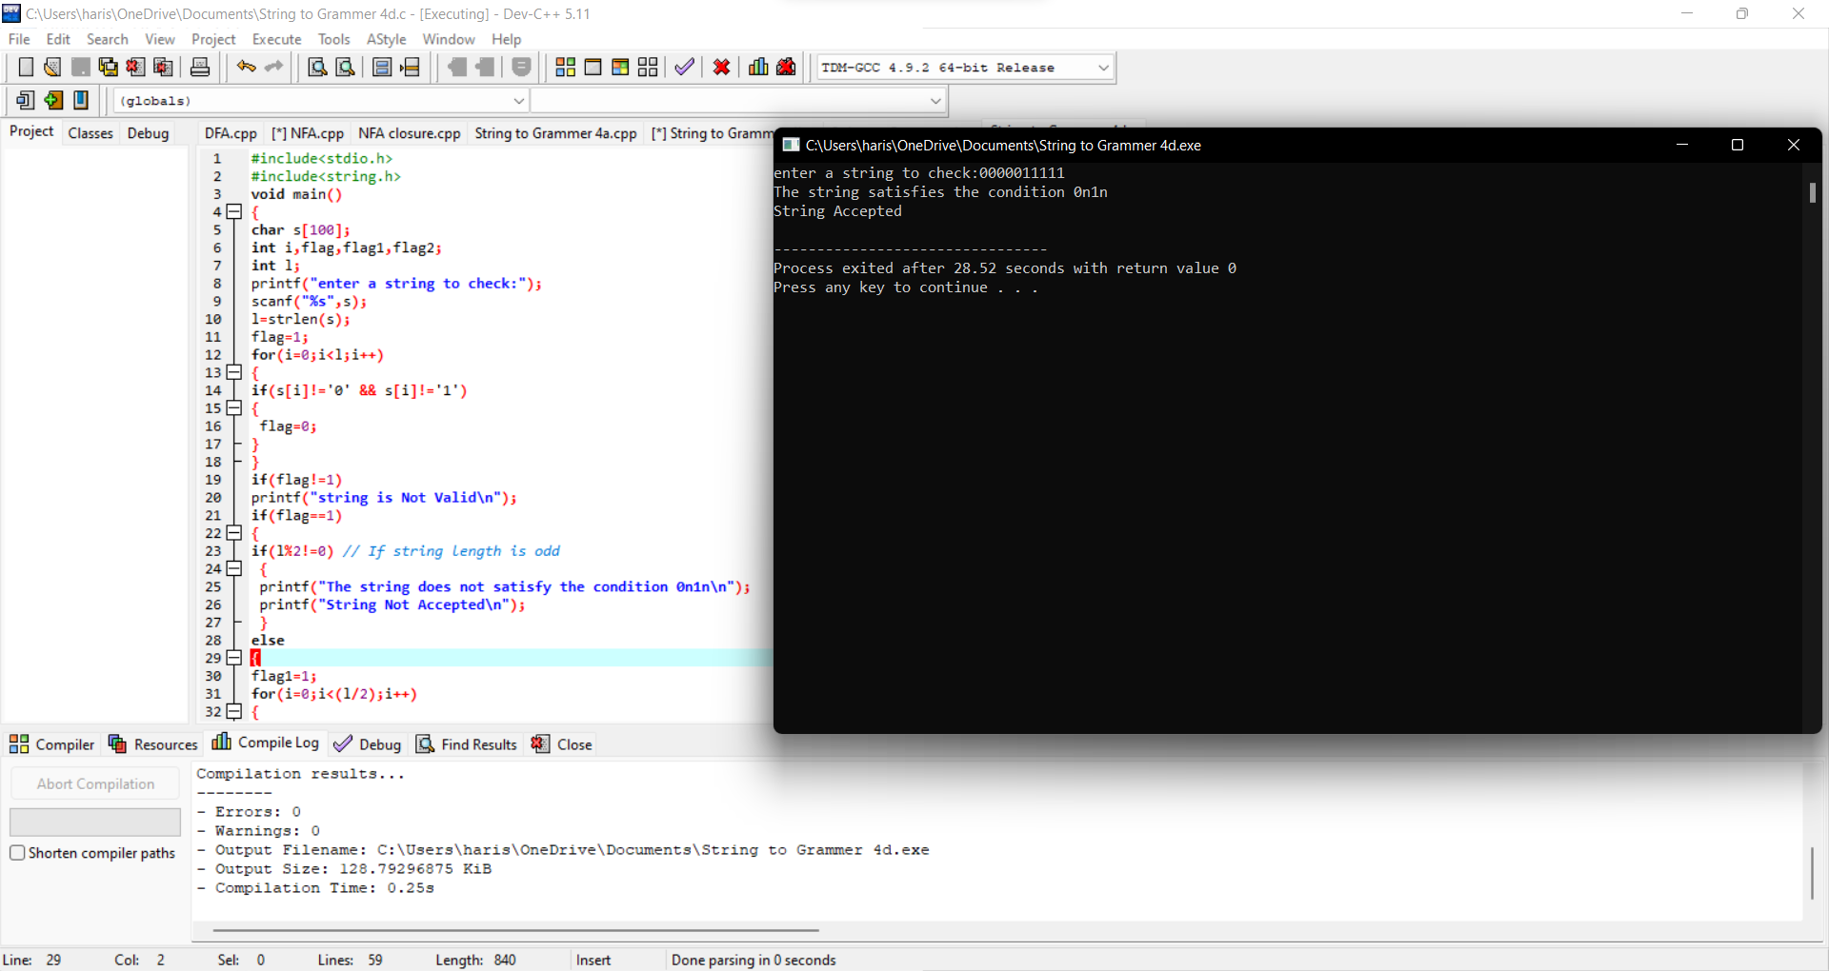

**4E.**

#include<stdio.h>

#include<string.h>

int main()

{

char s[100];

int i,flag,flag1;

int l;

printf("enter a string to check:");

scanf("%s",s);

l=strlen(s);

flag=1;

for(i=0;i<l;i++)

{

if(s[i]!='0' && s[i]!='1')

{

flag=0;

}

}

if(flag==1)

printf("string is Valid\n");

else

printf("string is Not Valid\n");

if(flag==1)

{

flag1=0;

for(i=0;i<l-2;i++)

{

if(s[i]=='1')

{

if(s[i+1]=='0' && s[i+2]=='1')

{

flag1=1;

printf("Substring 101 exists. String accepted\n");

break;

}

}

}

if(flag1==0)

printf("Substring 101 does not exist. String not accepted\n");

}

}

**OUTPUT:**

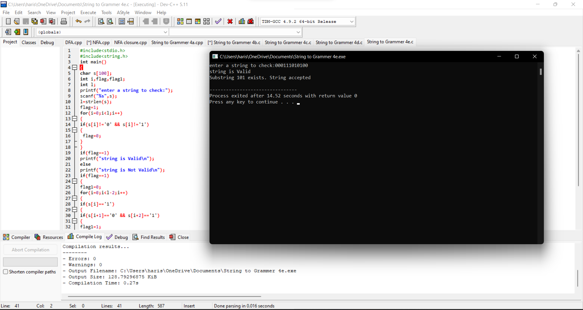

**SIMULATING PUSHDOWN AUTOMATA**

**5.PDA**

#include<stdio.h>

#include<string.h>

char stack[20];

int top;

void push()

{

top=top+1;

stack[top]='0';

stack[top+1]='\0';

}

int pop()

{

if(top<1)

return(0);

else

{

stack[top]='\0';

top=top-1;

return(1);

}

}

void main()

{

int m,i,j,k,l,a,len;

char input[20],rem_input[20];

printf("Simulation of Pushdown Automata for 0n1n\n");

printf("Enter a string : ");

scanf("%s",input);

l=strlen(input);

j=0;stack[0]='Z';top=0;

printf("Stack\tInput\n");

printf("%s\t%s\n",stack,input);

while(1)

{

len=strlen(input);

while(len>0)

{

if(input[0]=='0')

{

push();

m=0;

for(k=1;k<len;k++)

{

rem_input[m]=input[k];

m=m+1;

}

rem_input[m]='\0';

strcpy(input,rem_input);

printf("%s\t%s\n",stack,input);

}

if(input[0]=='1')

{

a=pop();

if(a==0)

{

printf("String not accepted");

goto b;

}

else

{

m=0;

for(k=1;k<len;k++)

{

rem_input[m]=input[k];

m=m+1;

}

rem_input[m]='\0';

strcpy(input,rem_input);

printf("%s\t%s\n",stack,input);

}

}

break;

}

j=j+1;

if(j==(l))

{

break;

}

}

if(top>=1)

{

printf("String not accepted");

}

else

{

printf("String accepted");

}

b:

printf(".............");

}

**OUTPUT:**

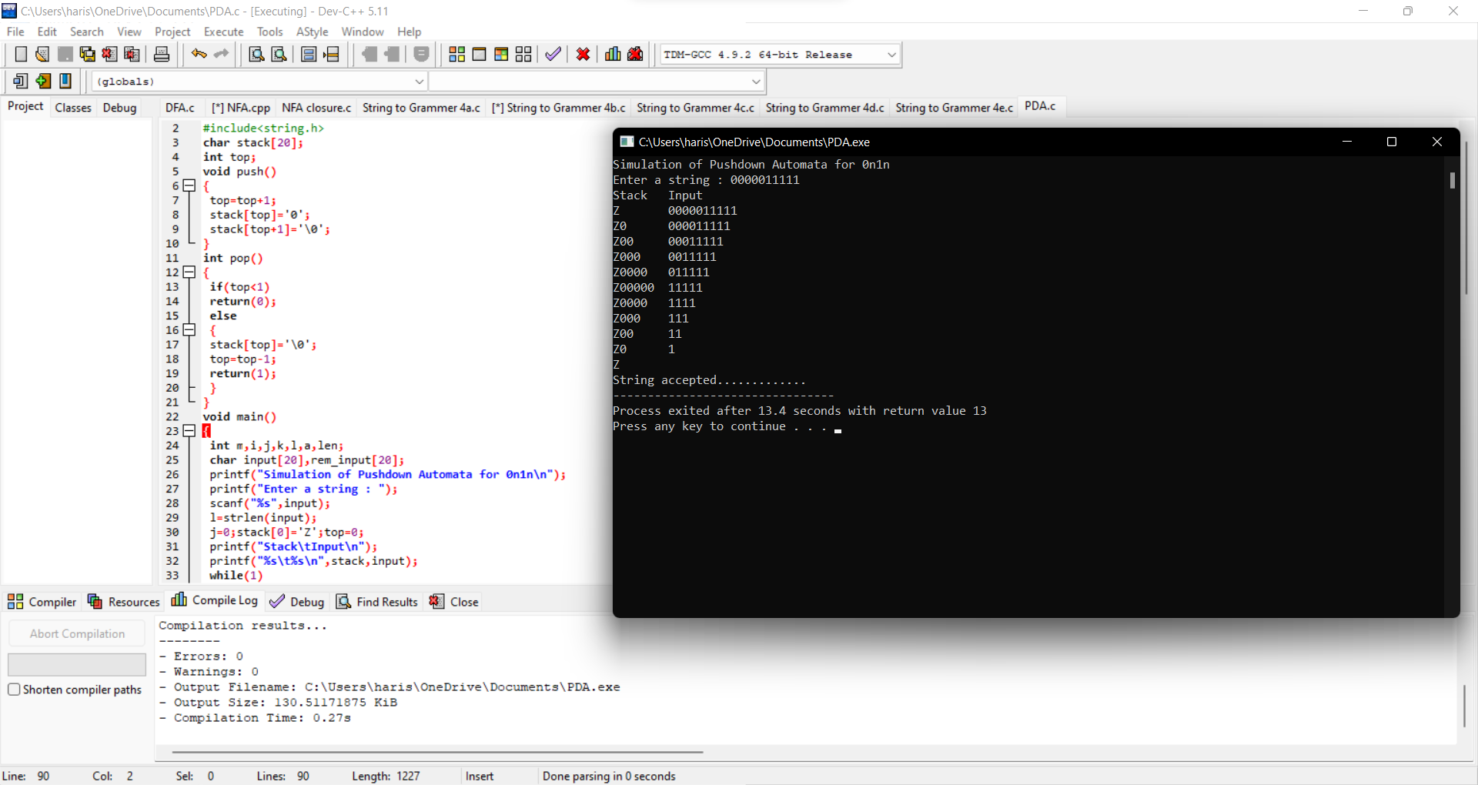

**6.PDA**

#include<stdio.h>

#include<string.h>

char stack[20];

int top,count=0;

void push()

{

top=top+1;

stack[top]='0';

stack[top+1]='\0';

}

int pop()

{

if(top<1)

return(0);

else

{

stack[top]='\0';

top=top-1;

return(1);

}

}

void main()

{

int m,i,j,k,l,a,len;

char input[20],rem_input[20];

printf("Simulation of PDA for n 0's followed by 2n 1's\n");

printf("Enter a string : ");

scanf("%s",input);

l=strlen(input);

j=0;stack[0]='Z';top=0;

printf("Stack\tInput\n");

printf("%s\t%s\n",stack,input);

while(1)

{

len=strlen(input);

while(len>0)

{

if(input[0]=='0')

{

push();

m=0;

for(k=1;k<len;k++)

{

rem_input[m]=input[k];

m=m+1;

}

rem_input[m]='\0';

strcpy(input,rem_input);

printf("%s\t%s\n",stack,input);

}

if(input[0]=='1')

{

count++;

if(count%2==0)

{

a=pop();

if(a==0)

{

printf("String not accepted");

goto b;

}

else

{

m=0;

for(k=1;k<len;k++)

{

rem_input[m]=input[k];

m=m+1;

}

}

rem_input[m]='\0';

strcpy(input,rem_input);

printf("%s\t%s\n",stack,input);

}

else

{

m=0;

for(k=1;k<len;k++)

{

rem_input[m]=input[k];

m=m+1;

}

rem_input[m]='\0';

strcpy(input,rem_input);

printf("%s\t%s\n",stack,input);

}

}

break;

}

j=j+1;

//printf("j = %d\t l = %d\n",j,l);

if(j==l)

{

break;

}

}

if(top>=1)

{

printf("String not accepted");

}

else

{

printf("String accepted");

}

b:

printf(".............");

}

**OUTPUT:**

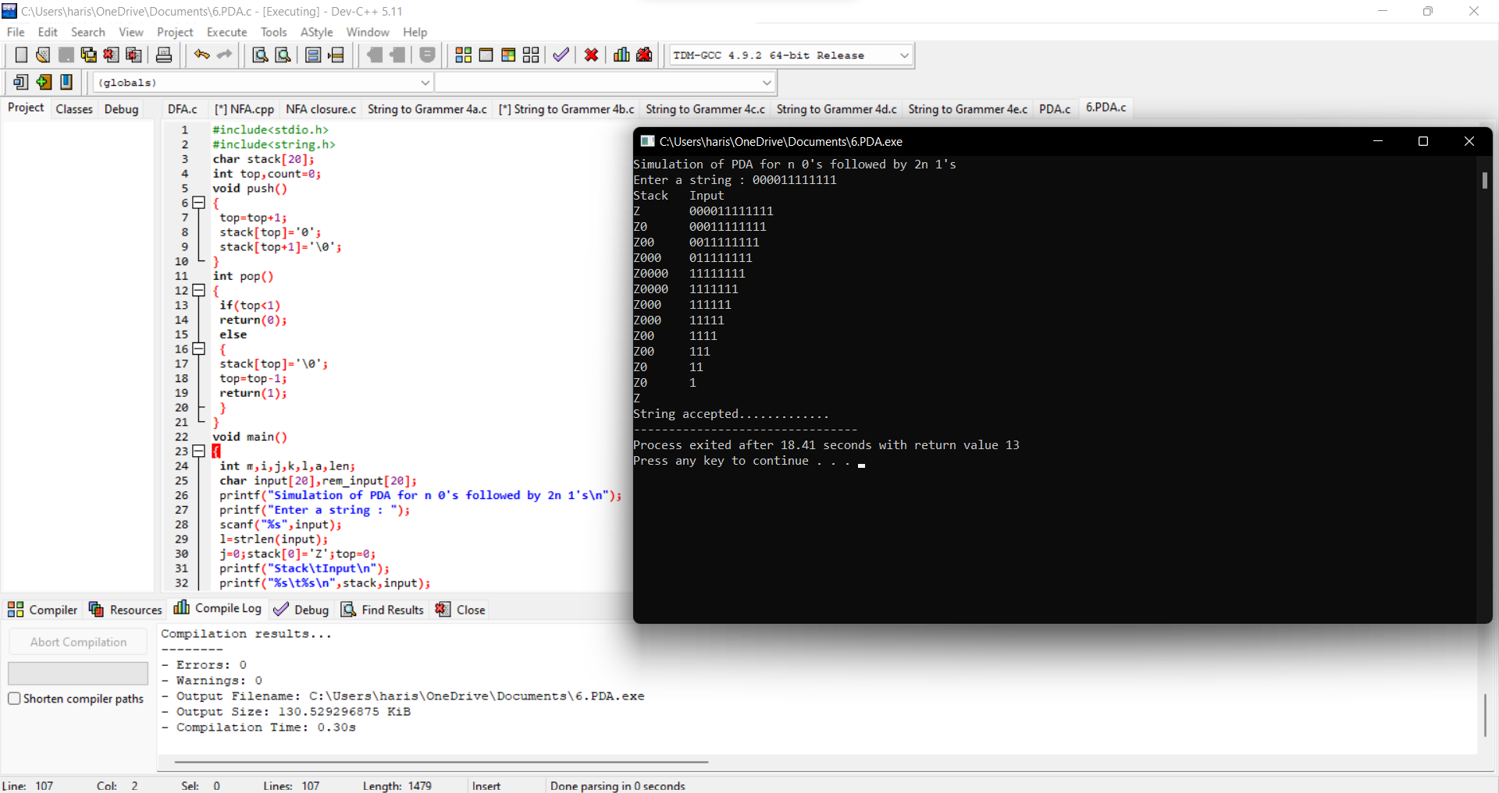

**TURNING MACHINE**

**7.TM**

#include<stdio.h>

#include<string.h>

void main()

{

int i,j,le,flag,flag1,flag2;

char str[20];

printf("Program to show how a turing machine will process 0n1n2n\n");

printf("Enter a string : ");

scanf("%s",str);

le=strlen(str);

j=0;

while(1)

{

flag=0;flag1=0;flag2=0;i=0;

while(i<le)

{

if((str[i]=='0')&&(flag==0))

{

str[i] = 'A';

printf("%s\n",str);

flag=1; //To mark that a 0 is changed to A

i=i+1;

}

else if((str[i]=='0')&&(flag==1))

{

i=i+1; //Skip 0

}

else if(str[i]=='A')

{

i=i+1; //Skip A

}

else if((str[i]=='1')&&(flag1==0))

{

str[i] = 'B';

printf("%s\n",str);

flag1=1; //To mark that a 1 is changed to B

i=i+1;

}

else if((str[i]=='1')&&(flag1==1))

{

i=i+1; //Skip 1

}

else if(str[i]=='B')

{

i=i+1; //Skip B

}

else if((str[i]=='2')&&(flag2==0))

{

str[i] ='C';

printf("%s\n",str);

flag2=1;

i=i+1;

}

else if((str[i]=='2')&&(flag2==1))

{

i=i+1; //Skip 2

}

else if(str[i]=='C')

{

i=i+1; //Skip C

}

}

j=j+1;

if(j==le)

{

break;

}

}

}

**OUTPUT:**

